MODULE-1
Automation with Selenium

Module | Automation with Selenium
Module Focus | Selenium WebDriver, locators, synchronization, web controls, alerts, tables, windows, tabs, and iframes
Language | Python
Browser | Google Chrome
Automation Framework | Selenium WebDriver
Experiments Covered | Assignment 1 to Assignment 6

Experiment List
Experiment | Title | Primary Concepts
1 | The Multi-Locator Challenge | ID, NAME, XPath, URL assertion
2 | Synchronization & Explicit Waits | WebDriverWait, expected_conditions
3 | Dynamic Dropdowns & Checkboxes | Checkboxes, is_selected(), autocomplete
4 | JavaScript Alerts and Confirms | Alert, Confirm, Prompt
5 | The HTML Web Table Extractor | Rows, columns, text extraction
6 | Windows, Tabs, and Iframes | iframe, window_handles, tab switching

Experiment 1: The Multi-Locator Challenge
Module | Automation with Selenium
Experiment Title | The Multi-Locator Challenge
Practice Website | https://www.saucedemo.com/

Problem Statement
Automate a login page using multiple Selenium locator strategies. The username field must be located by ID, the password field by NAME, and the login button by XPath. The successful login must be validated by checking the resulting URL.

Objective
To practice identifying and interacting with web elements using different locator strategies and to validate a successful browser action using an assertion.

Tools, Software, and Concepts Used
- Python 3
- Selenium WebDriver 4
- Google Chrome
- PyCharm / Python IDE

Implementation Steps
- Open the SauceDemo login page.
- Locate the username field using its ID and enter the valid username.
- Locate the password field using its NAME and enter the password.
- Locate the login button using XPath and click it.
- Wait until the URL contains /inventory.html.
- Assert the expected URL condition and close the browser.

Source Code
from selenium import webdriver
from selenium.webdriver.common.by import By
from selenium.webdriver.support.ui import WebDriverWait
from selenium.webdriver.support import expected_conditions as EC

# Create Chrome browser instance
driver = webdriver.Chrome()

try:
# Open SauceDemo login page
driver.get("https://www.saucedemo.com/")

# Maximize browser
driver.maximize_window()

# Wait until username field is visible
username = WebDriverWait(driver, 10).until(
EC.visibility_of_element_located((By.ID, "user-name"))
)

# Find username using ID
username.send_keys("standard_user")

# Find password using NAME
password = driver.find_element(By.NAME, "password")
password.send_keys("secret_sauce")

# Find login button using XPATH
login_button = driver.find_element(
By.XPATH, "//input[@type='submit']"
)

# Click login
login_button.click()

# Wait until URL contains inventory.html
WebDriverWait(driver, 10).until(
EC.url_contains("/inventory.html")
)

# Get current URL
current_url = driver.current_url

# Validate URL
assert "/inventory.html" in current_url

print("Assignment 1 PASSED")
print("Login successful!")
print("Current URL:", current_url)

finally:
driver.quit()

Output / Screenshots
Run the program and paste the corresponding screenshots in the spaces below.
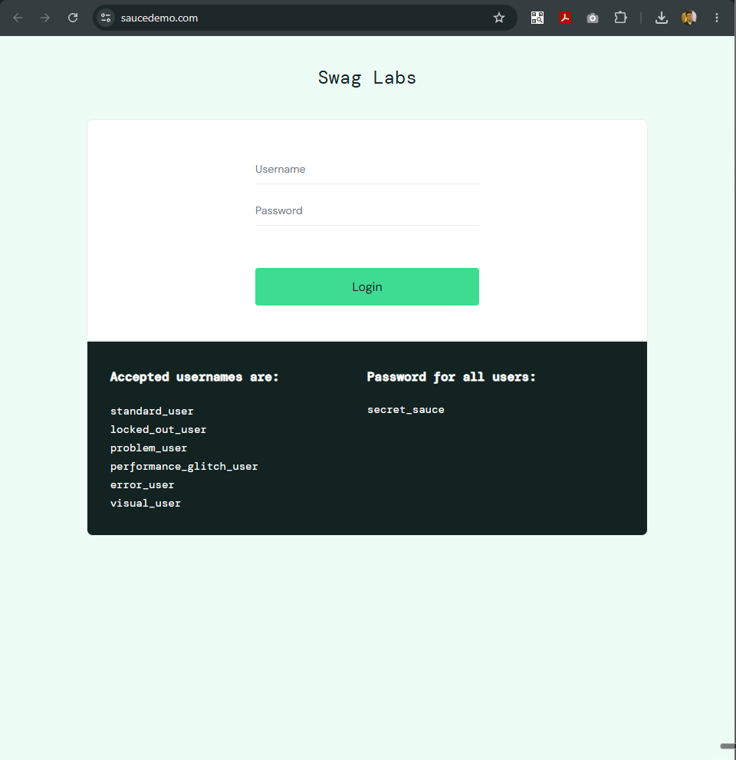
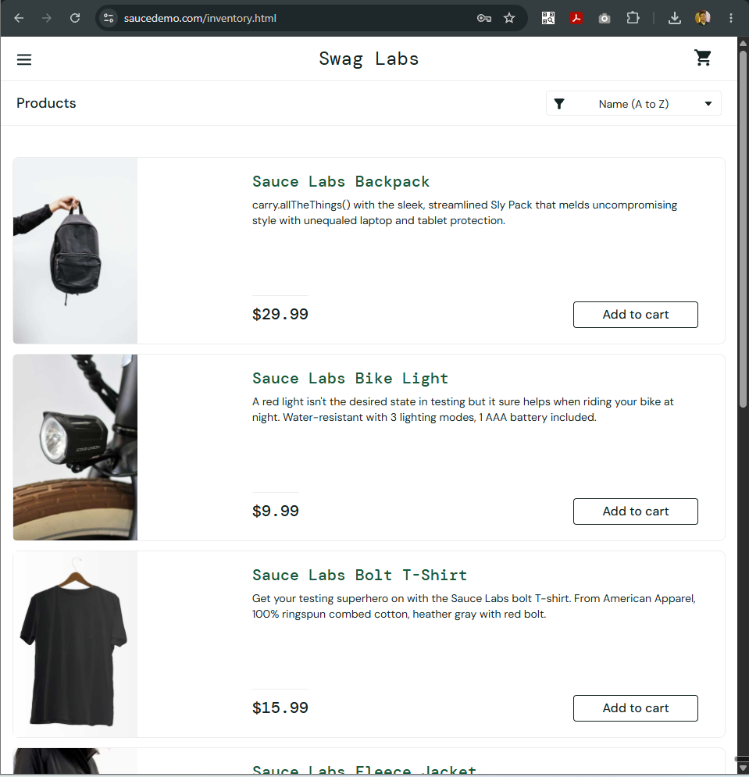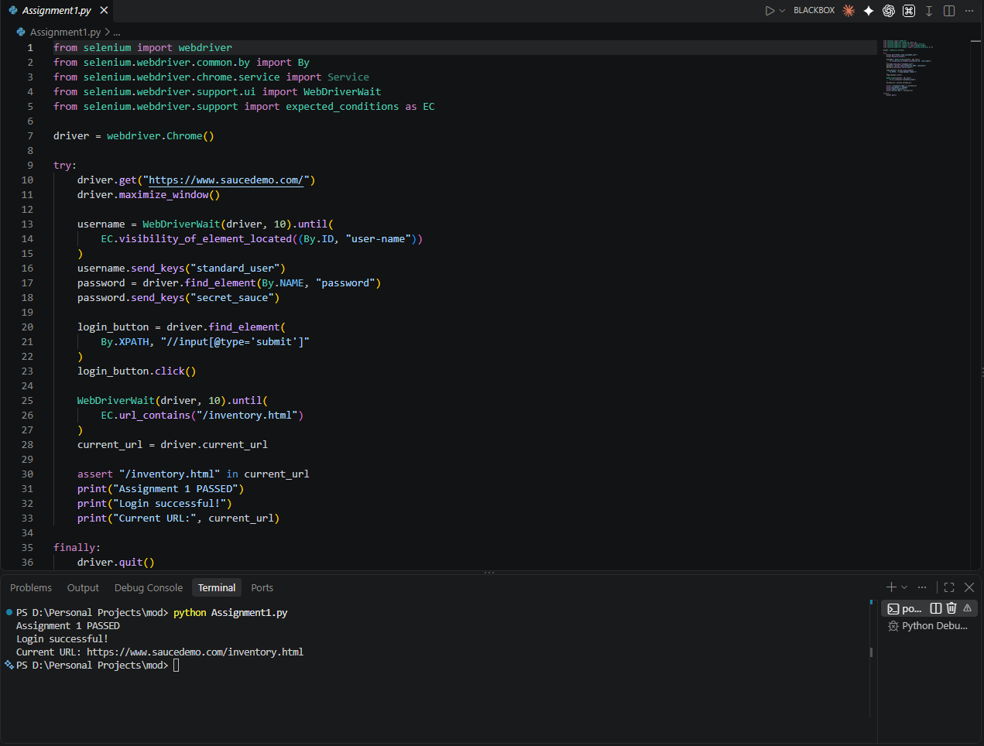

Expected Output
Assignment 1 PASSED
Login successful!
Current URL: https://www.saucedemo.com/inventory.html

Result and Observation
The login page was automated successfully using three different locator strategies. The URL assertion confirmed that the browser reached the inventory page after authentication.

Conclusion
The experiment demonstrated practical use of Selenium locators, browser interaction methods, explicit synchronization, and assertions for validation.

Experiment 2: Synchronization & Explicit Waits
Module | Automation with Selenium
Experiment Title | Synchronization & Explicit Waits
Practice Website | https://the-internet.herokuapp.com/dynamic_loading/1

Problem Statement
Automate a page containing dynamically loaded content. The script must not use time.sleep(); instead, it must wait explicitly until the required element becomes visible.

Objective
To understand synchronization problems in web automation and implement WebDriverWait with expected_conditions for reliable interaction with dynamic elements.

Tools, Software, and Concepts Used
- Python 3
- Selenium WebDriver 4
- Google Chrome
- PyCharm / Python IDE
Key concepts:
- WebDriverWait
- expected_conditions
- element_to_be_clickable
- visibility_of_element_located
- dynamic content
- explicit synchronization

Implementation Steps
- Open the dynamic-loading page.
- Wait until the Start button is clickable.
- Click the Start button.
- Wait until the dynamically generated text element becomes visible.
- Extract the text and verify that it is Hello World!.
- Print the successful result and close the browser.

Source Code
from selenium import webdriver
from selenium.webdriver.common.by import By
from selenium.webdriver.support.ui import WebDriverWait
from selenium.webdriver.support import expected_conditions as EC

# Create Chrome browser
driver = webdriver.Chrome()

try:
# Open dynamic loading page
driver.get(
"https://the-internet.herokuapp.com/dynamic_loading/1"
)

# Maximize browser
driver.maximize_window()

print("Page opened successfully.")

# Locate Start button
start_button = WebDriverWait(driver, 10).until(
EC.element_to_be_clickable(
(By.XPATH, "//button[text()='Start']")
)
)

print("Start button found.")

# Click Start
start_button.click()

print("Waiting for dynamic content...")

# Wait until dynamically loaded text is visible
text_element = WebDriverWait(driver, 15).until(
EC.visibility_of_element_located(
(By.XPATH, "//div[@id='finish']/h4")
)
)

# Extract text
text = text_element.text

print("Dynamic content:", text)

# Validate text
assert text == "Hello World!"

print("Assignment 2 PASSED")

finally:
driver.quit()

Output / Screenshots
Run the program and paste the corresponding screenshots in the spaces below.
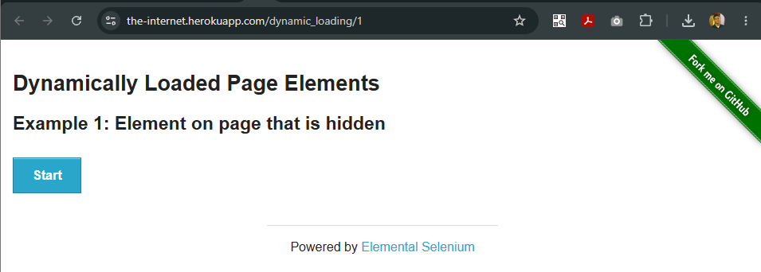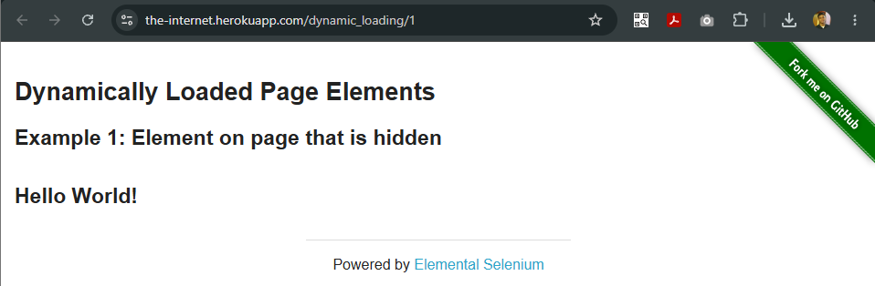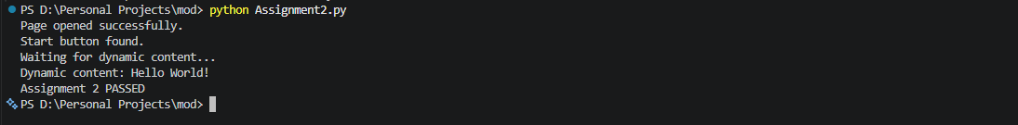
Expected Output
Page opened successfully.
Start button found.
Waiting for dynamic content...
Dynamic content: Hello World!
Assignment 2 PASSED

Result and Observation
The dynamic text was retrieved without using time.sleep(). WebDriverWait waited only until the required condition was satisfied, demonstrating reliable explicit synchronization.

Conclusion
The experiment demonstrated why explicit waits are preferred over fixed delays when working with dynamically changing web pages.

Experiment 3: Dynamic Dropdowns & Checkboxes
Module | Automation with Selenium
Experiment Title | Dynamic Dropdowns & Checkboxes
Practice Website | https://demoqa.com/automation-practice-form

Problem Statement
Automate a registration form containing multiple checkboxes and a search-as-you-type autocomplete field. The selected state of the checkboxes must be verified and a matching autocomplete option must be selected.

Objective
To practice checkbox handling, state verification using is_selected(), dynamic suggestion handling, CSS selectors, and iteration through WebElements.

Tools, Software, and Concepts Used
- Python 3
- Selenium WebDriver 4
- Google Chrome
- PyCharm / Python IDE
Key concepts:
- Checkbox selection
- is_selected()
- XPath
- CSS selectors
- autocomplete
- find_elements()
- WebDriverWait
- looping through WebElements
- dynamic DOM handling

Implementation Steps
- Open the DemoQA automation practice form.
- Locate and select the Sports checkbox.
- Verify that the Sports checkbox is selected.
- Locate and select the Reading checkbox.
- Verify that the Reading checkbox is selected.
- Type Math into the Subjects autocomplete field.
- Wait for suggestions and iterate through them.
- Select the Maths suggestion and print the successful result.

Source Code
from selenium import webdriver
from selenium.webdriver.common.by import By
from selenium.webdriver.support.ui import WebDriverWait
from selenium.webdriver.support import expected_conditions as EC

# Initialize Chrome WebDriver
driver = webdriver.Chrome()
wait = WebDriverWait(driver, 10)

try:
# Open DemoQA registration page
driver.get("https://demoqa.com/automation-practice-form")

driver.maximize_window()

print("Registration page opened.")

# --------------------------------------------------
# 1. SELECT CHECKBOXES
# --------------------------------------------------

# Sports checkbox
sports_checkbox = wait.until(
EC.element_to_be_clickable(
(By.XPATH, "//label[text()='Sports']")
)
)

sports_checkbox.click()

# Get the actual checkbox input
sports_input = driver.find_element(
By.ID, "hobbies-checkbox-1"
)

print(
"Sports selected:",
sports_input.is_selected()
)

# Reading checkbox
reading_checkbox = wait.until(
EC.element_to_be_clickable(
(By.XPATH, "//label[text()='Reading']")
)
)

reading_checkbox.click()

# Get actual checkbox input
reading_input = driver.find_element(
By.ID, "hobbies-checkbox-2"
)

print(
"Reading selected:",
reading_input.is_selected()
)

# Verify checkbox states
assert sports_input.is_selected(), \
"Sports checkbox was not selected."

assert reading_input.is_selected(), \
"Reading checkbox was not selected."

# --------------------------------------------------
# 2. AUTOCOMPLETE DROPDOWN
# --------------------------------------------------

# Locate autocomplete input
subject_input = wait.until(
EC.element_to_be_clickable(
(By.ID, "subjectsInput")
)
)

# Type search text
subject_input.send_keys("Math")

print("Typed 'Math' into autocomplete field.")

# Wait for autocomplete suggestion
wait.until(
EC.visibility_of_element_located(
(
By.CSS_SELECTOR,
".subjects-auto-complete__option"
)
)
)

# Find all suggestions
suggestions = driver.find_elements(
By.CSS_SELECTOR,
".subjects-auto-complete__option"
)

print("Suggestions found:")

target_option = "Maths"

for suggestion in suggestions:

# Store text BEFORE clicking
suggestion_text = suggestion.text.strip()

print("-", suggestion_text)

if suggestion_text == target_option:

# Click the matching suggestion
suggestion.click()

print(
"Matching option selected:",
suggestion_text
)

break

else:
raise Exception(
f"Autocomplete option '{target_option}' "
f"was not found."
)

print("Assignment 3 PASSED")

finally:
driver.quit()

Output / Screenshots
Run the program and paste the corresponding screenshots in the spaces below.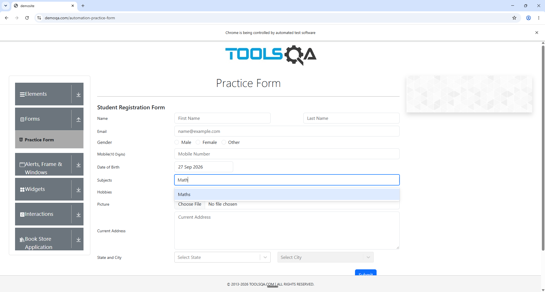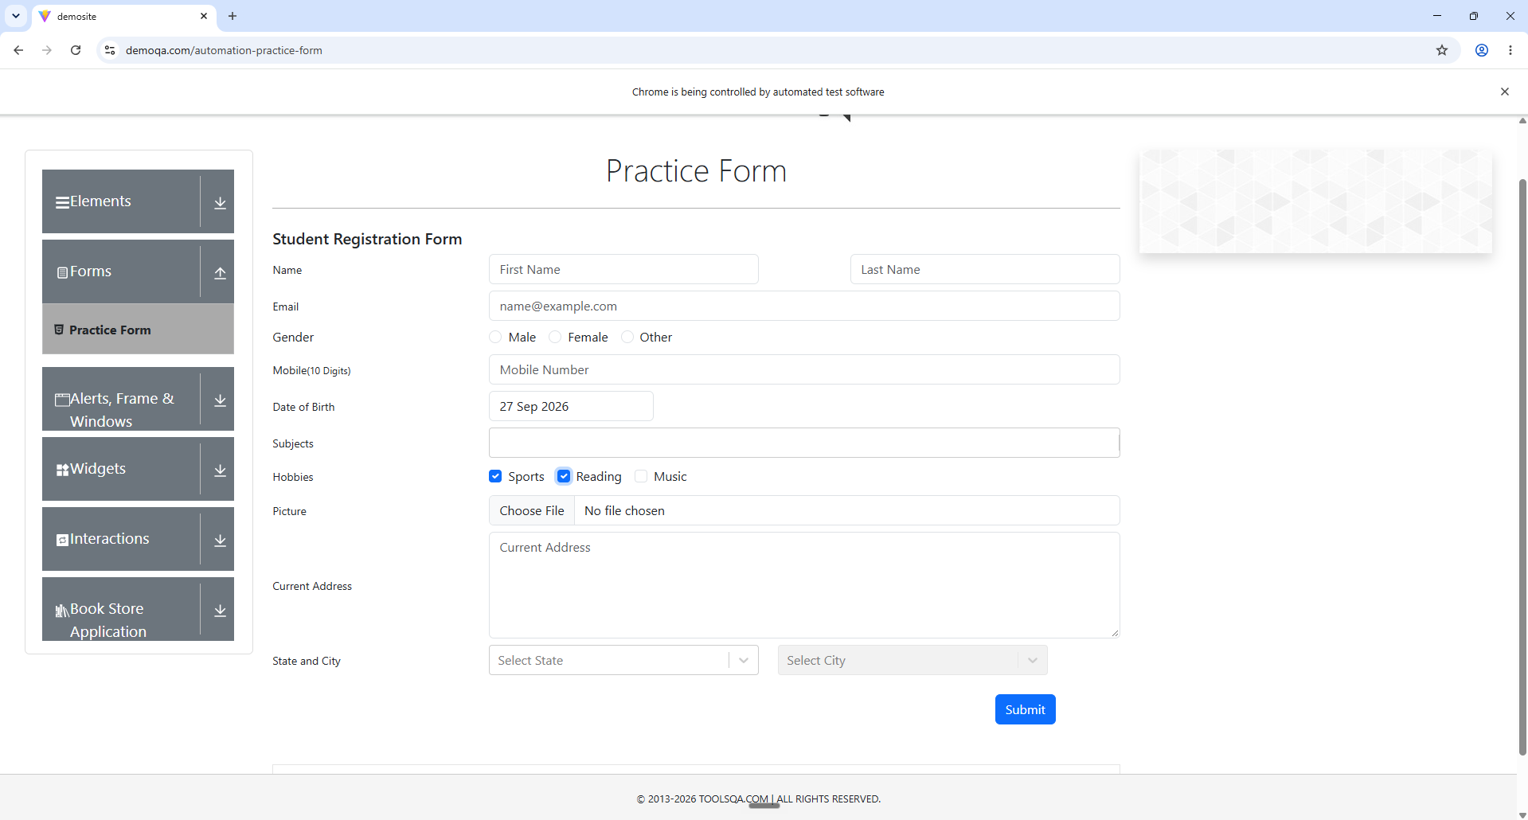
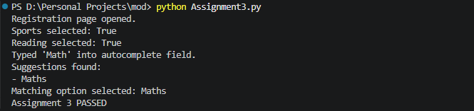

Expected Output
Registration page opened.
Sports selected: True
Reading selected: True
Typed 'Math' into autocomplete field.
Suggestions found:
- Maths
Matching option selected: Maths
Assignment 3 PASSED

Result and Observation
Both checkboxes were selected and verified using is_selected(). The autocomplete field produced a dynamic suggestion, and the script located and selected the required Maths option. The suggestion text was stored before clicking to avoid a stale element reference after the DOM update.

Conclusion
The experiment demonstrated practical automation of checkboxes and dynamic autocomplete controls, including synchronization and handling of changing DOM elements.

Experiment 4: JavaScript Alerts and Confirms
Module | Automation with Selenium
Experiment Title | JavaScript Alerts and Confirms
Practice Website | https://the-internet.herokuapp.com/javascript_alerts

Problem Statement
Automate three JavaScript dialog types: an alert, a confirm box, and a prompt box. The alert must be accepted, the confirm dismissed, and text entered into the prompt before it is submitted.

Objective
To learn how Selenium switches from the normal page context to JavaScript alert dialogs and performs accept, dismiss, and text-entry operations.

Tools, Software, and Concepts Used
- Python 3
- Selenium WebDriver 4
- Google Chrome
- PyCharm / Python IDE
Key concepts:
- driver.switch_to.alert
- alert.text
- accept()
- dismiss()
- send_keys()
- alert_is_present()
- JavaScript dialogs

Implementation Steps
- Open the JavaScript Alerts page.
- Click the JS Alert button and wait for the alert.
- Read its message and accept it.
- Click the JS Confirm button and dismiss the confirm dialog.
- Click the JS Prompt button and wait for the prompt.
- Enter Selenium Test using send_keys().
- Accept the prompt and print the successful result.

Source Code
from selenium import webdriver
from selenium.webdriver.common.by import By
from selenium.webdriver.support.ui import WebDriverWait
from selenium.webdriver.support import expected_conditions as EC

# Initialize Chrome WebDriver
driver = webdriver.Chrome()
wait = WebDriverWait(driver, 10)

try:
# Open JavaScript Alerts page
driver.get("https://the-internet.herokuapp.com/javascript_alerts")

driver.maximize_window()

print("JavaScript Alerts page opened.")

# --------------------------------------------------
# 1. JAVASCRIPT ALERT
# --------------------------------------------------

alert_button = wait.until(
EC.element_to_be_clickable(
(By.XPATH, "//button[text()='Click for JS Alert']")
)
)

alert_button.click()

alert = wait.until(EC.alert_is_present())

print("Alert message:", alert.text)

# Accept the alert
alert.accept()

print("Alert accepted.")

# --------------------------------------------------
# 2. JAVASCRIPT CONFIRM
# --------------------------------------------------

confirm_button = wait.until(
EC.element_to_be_clickable(
(By.XPATH, "//button[text()='Click for JS Confirm']")
)
)

confirm_button.click()

confirm = wait.until(EC.alert_is_present())

print("Confirm message:", confirm.text)

# Dismiss the confirm box
confirm.dismiss()

print("Confirm dismissed.")

# --------------------------------------------------
# 3. JAVASCRIPT PROMPT
# --------------------------------------------------

prompt_button = wait.until(
EC.element_to_be_clickable(
(By.XPATH, "//button[text()='Click for JS Prompt']")
)
)

prompt_button.click()

prompt = wait.until(EC.alert_is_present())

print("Prompt message:", prompt.text)

# Enter text into prompt
prompt.send_keys("Selenium Test")

print("Text entered into prompt.")

# Submit prompt
prompt.accept()

print("Prompt accepted.")

print("Assignment 4 PASSED")

finally:
driver.quit()

Output / Screenshots
Run the program and paste the corresponding screenshots in the spaces below.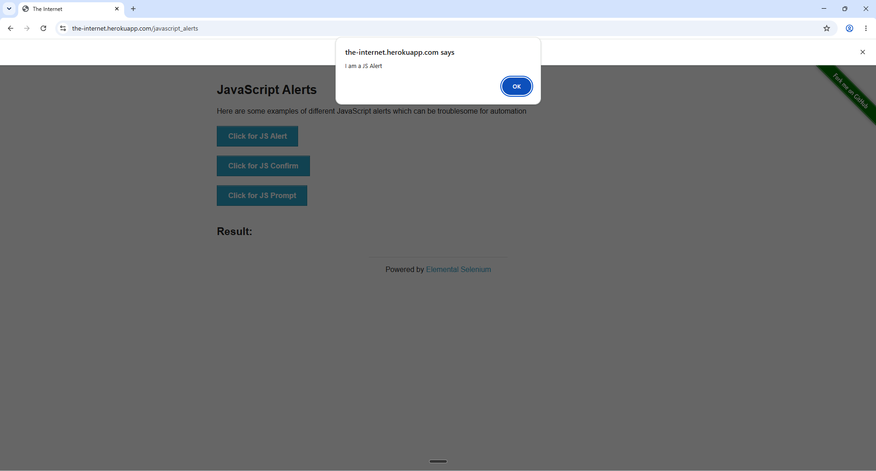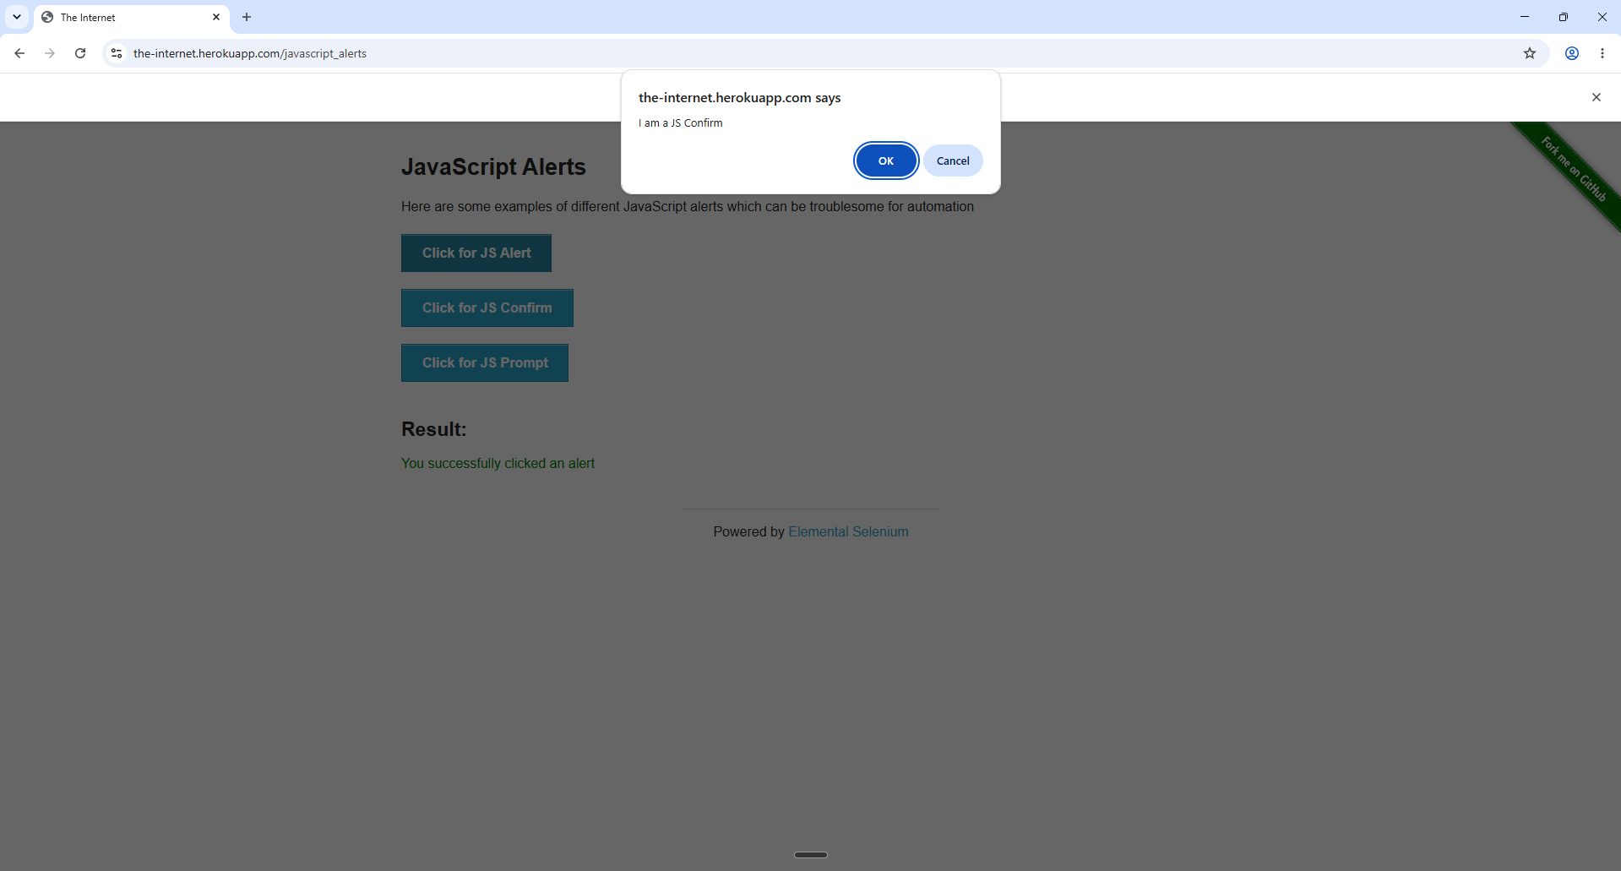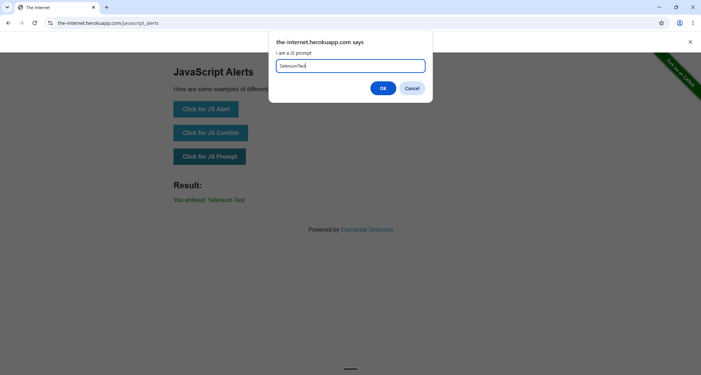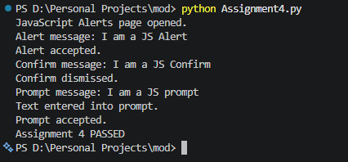

Expected Output
JavaScript Alerts page opened.
Alert message: I am a JS Alert
Alert accepted.
Confirm message: I am a JS Confirm
Confirm dismissed.
Prompt message: I am a JS prompt
Text entered into prompt.
Prompt accepted.
Assignment 4 PASSED

Result and Observation
All three JavaScript dialog types were successfully handled. The alert was accepted, the confirm was dismissed, and text was entered into the prompt before accepting it.

Conclusion
The experiment demonstrated Selenium's alert-handling API and the difference between accepting, dismissing, and entering data into JavaScript dialogs.

Experiment 5: The HTML Web Table Extractor
Module | Automation with Selenium
Experiment Title | The HTML Web Table Extractor
Practice Website | https://the-internet.herokuapp.com/tables

Problem Statement
Automate a multi-column HTML data table. The script must iterate through rows and columns, display the table data, identify a particular row by matching a name, and retrieve the corresponding Due value from that row.

Objective
To understand the structure of HTML tables and use Selenium to traverse headers, rows, and individual table cells.

Tools, Software, and Concepts Used
- Python 3
- Selenium WebDriver 4
- Google Chrome
- PyCharm / Python IDE
Key concepts:
- Web tables
- find_elements()
- CSS selectors
- Tag Name locator
- rows and columns
- .text
- nested element search
- row matching

Implementation Steps
- Open the sortable tables page.
- Locate table1.
- Read and print all table headers.
- Locate all body rows.
- Iterate through every row and its cells and print the data.
- Search for the row whose Last Name is Smith.
- Retrieve the Due value from the matching row.
- Display the extracted value and finish the experiment.

Source Code
from selenium import webdriver
from selenium.webdriver.common.by import By
from selenium.webdriver.support.ui import WebDriverWait
from selenium.webdriver.support import expected_conditions as EC

# Initialize Chrome WebDriver
driver = webdriver.Chrome()
wait = WebDriverWait(driver, 10)

try:
# Open table page
driver.get("https://the-internet.herokuapp.com/tables")

driver.maximize_window()

print("Web table page opened.")

# --------------------------------------------------
# 1. LOCATE TABLE
# --------------------------------------------------

table = wait.until(
EC.visibility_of_element_located(
(By.ID, "table1")
)
)

# --------------------------------------------------
# 2. READ TABLE HEADERS
# --------------------------------------------------

headers = table.find_elements(
By.CSS_SELECTOR,
"thead th"
)

header_names = []

for header in headers:
header_names.append(header.text.strip())

print("\nTable Headers:")
print(header_names)

# --------------------------------------------------
# 3. READ ALL ROWS
# --------------------------------------------------

rows = table.find_elements(
By.CSS_SELECTOR,
"tbody tr"
)

print("\nTable Data:")

for row in rows:

columns = row.find_elements(
By.TAG_NAME,
"td"
)

row_data = []

for column in columns:
row_data.append(column.text.strip())

print(row_data)

# --------------------------------------------------
# 4. FIND SPECIFIC PERSON
# --------------------------------------------------

target_name = "Smith"

target_due = None

for row in rows:

columns = row.find_elements(
By.TAG_NAME,
"td"
)

# Last Name is column 0
last_name = columns[0].text.strip()

if last_name == target_name:

# Due is column 3
target_due = columns[3].text.strip()

break

# --------------------------------------------------
# 5. DISPLAY RESULT
# --------------------------------------------------

if target_due is not None:

print("\nTarget person found:", target_name)
print("Due value:", target_due)

else:

print("\nPerson not found:", target_name)

print("\nAssignment 5 PASSED")

finally:
driver.quit()

Output / Screenshots
Run the program and paste the corresponding screenshots in the spaces below.
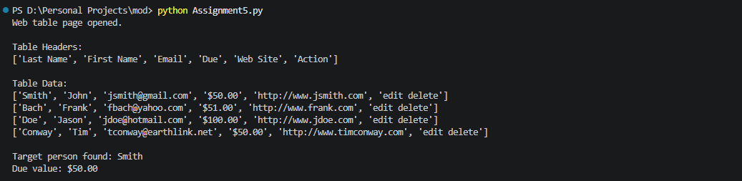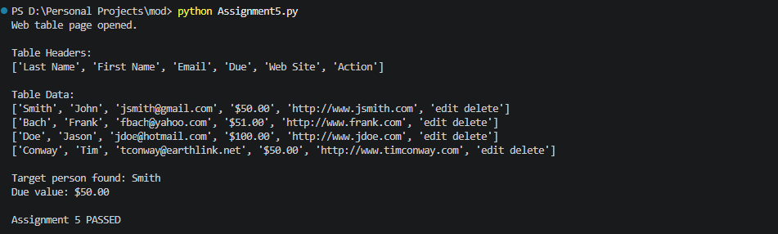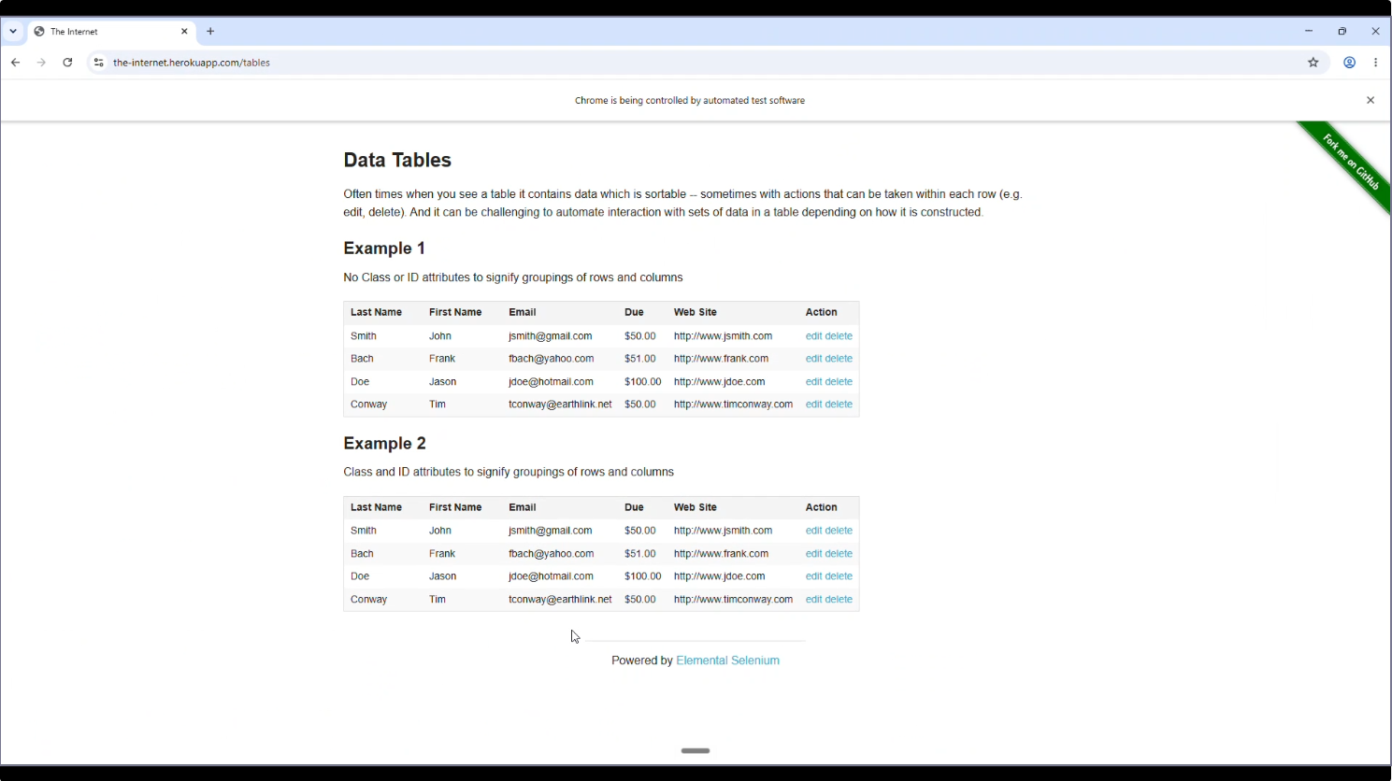

Expected Output
Web table page opened.

Table Headers:
['Last Name', 'First Name', 'Email', 'Due', 'Web Site', 'Action']

Table Data:
[table rows displayed here]

Target person found: Smith
Due value: $50.00

Assignment 5 PASSED

Result and Observation
The script successfully located the HTML table, extracted its headers, traversed each row and column, and retrieved the Due value associated with the row whose Last Name matched Smith.

Conclusion
The experiment demonstrated how Selenium can be used to traverse structured HTML data and extract a value from the same row as a matching record.

Experiment 6: Windows, Tabs, and Iframes
Module | Automation with Selenium
Experiment Title | Windows, Tabs, and Iframes
Practice Website | https://the-internet.herokuapp.com/iframe and https://the-internet.herokuapp.com/windows

Problem Statement
Automate a page containing an embedded iframe and a separate page containing a link that opens a new browser window/tab. The script must switch into the iframe, interact with its editor, switch back, open the new window, obtain its title, close it, and return to the original window.

Objective
To learn how Selenium manages different browsing contexts, including iframe contexts and multiple browser windows/tabs.

Tools, Software, and Concepts Used
- Python 3
- Selenium WebDriver 4
- Google Chrome
- PyCharm / Python IDE
Key concepts:
- switch_to.frame()
- switch_to.default_content()
- current_window_handle
- window_handles
- switch_to.window()
- close()
- iframe
- multiple windows/tabs
- Keys.CONTROL

Implementation Steps
- Open the iframe page.
- Locate the iframe and switch Selenium into it.
- Locate the TinyMCE editor.
- Click the editor, select its existing content using Ctrl+A, delete it, and enter new text.
- Switch back to the main document.
- Open the Windows page and store the original window handle.
- Click the link that opens the new window.
- Wait for two window handles and switch to the new window.
- Read and print its title.
- Close the new window and switch back to the original window.

Source Code
from selenium import webdriver
from selenium.webdriver.common.by import By
from selenium.webdriver.common.keys import Keys
from selenium.webdriver.support.ui import WebDriverWait
from selenium.webdriver.support import expected_conditions as EC

# Initialize Chrome WebDriver
driver = webdriver.Chrome()
wait = WebDriverWait(driver, 10)

try:

# ==================================================
# PART 1: IFRAME
# ==================================================

driver.get(
"https://the-internet.herokuapp.com/iframe"
)

driver.maximize_window()

print("Iframe page opened.")

# Wait for iframe
iframe = wait.until(
EC.presence_of_element_located(
(By.ID, "mce_0_ifr")
)
)

# Switch into iframe
driver.switch_to.frame(iframe)

print("Switched into iframe.")

# Wait for editor
editor = wait.until(
EC.element_to_be_clickable(
(By.ID, "tinymce")
)
)

# Click inside editor
editor.click()

# Select existing text
editor.send_keys(
Keys.CONTROL,
"a"
)

# Delete existing text
editor.send_keys(
Keys.BACKSPACE
)

# Enter new text
editor.send_keys(
"Hello from Selenium!"
)

print("Text entered inside iframe.")

# Switch back to main document
driver.switch_to.default_content()

print("Switched back to main page.")

# ==================================================
# PART 2: NEW TAB / WINDOW
# ==================================================

driver.get(
"https://the-internet.herokuapp.com/windows"
)

print("\nWindows page opened.")

# Store original window handle
original_window = driver.current_window_handle

# Find button/link that opens new window
new_window_button = wait.until(
EC.element_to_be_clickable(
(By.LINK_TEXT, "Click Here")
)
)

# Click it
new_window_button.click()

# Wait for new window
wait.until(
EC.number_of_windows_to_be(2)
)

# Get all window handles
windows = driver.window_handles

print(
"Number of windows:",
len(windows)
)

# Switch to new window
for window in windows:

if window != original_window:

driver.switch_to.window(window)

break

# Get new window title
new_window_title = driver.title

print(
"New window title:",
new_window_title
)

# Close new window
driver.close()

print("New window closed.")

# Switch back to original window
driver.switch_to.window(
original_window
)

print(
"Switched back to original window."
)

print("\nAssignment 6 PASSED")

finally:
driver.quit()

Output / Screenshots
Run the program and paste the corresponding screenshots in the spaces below.
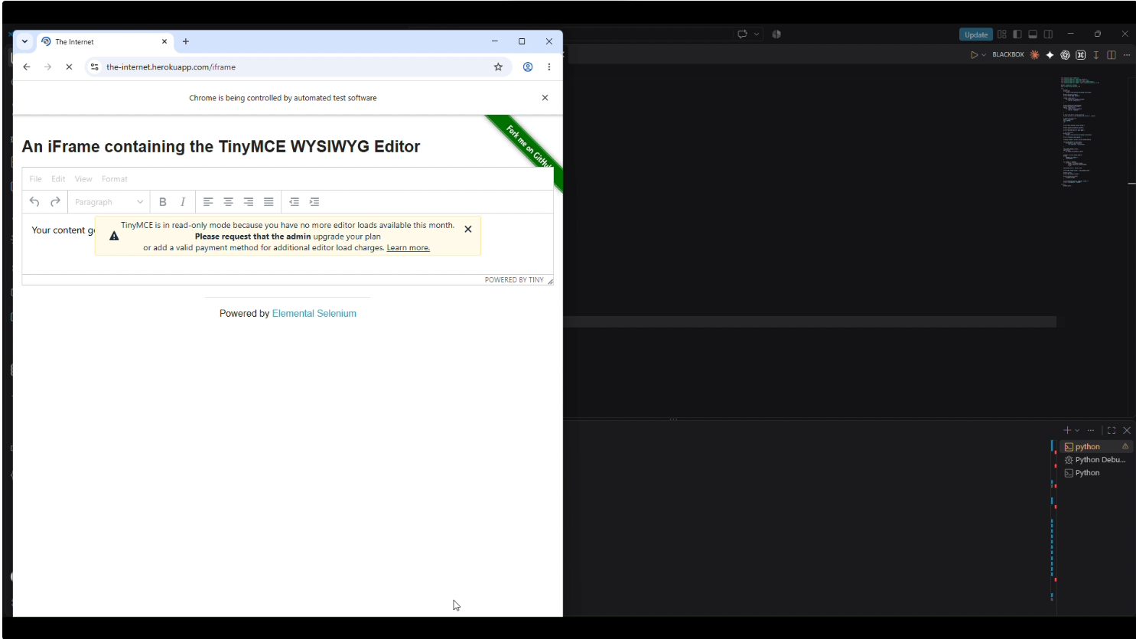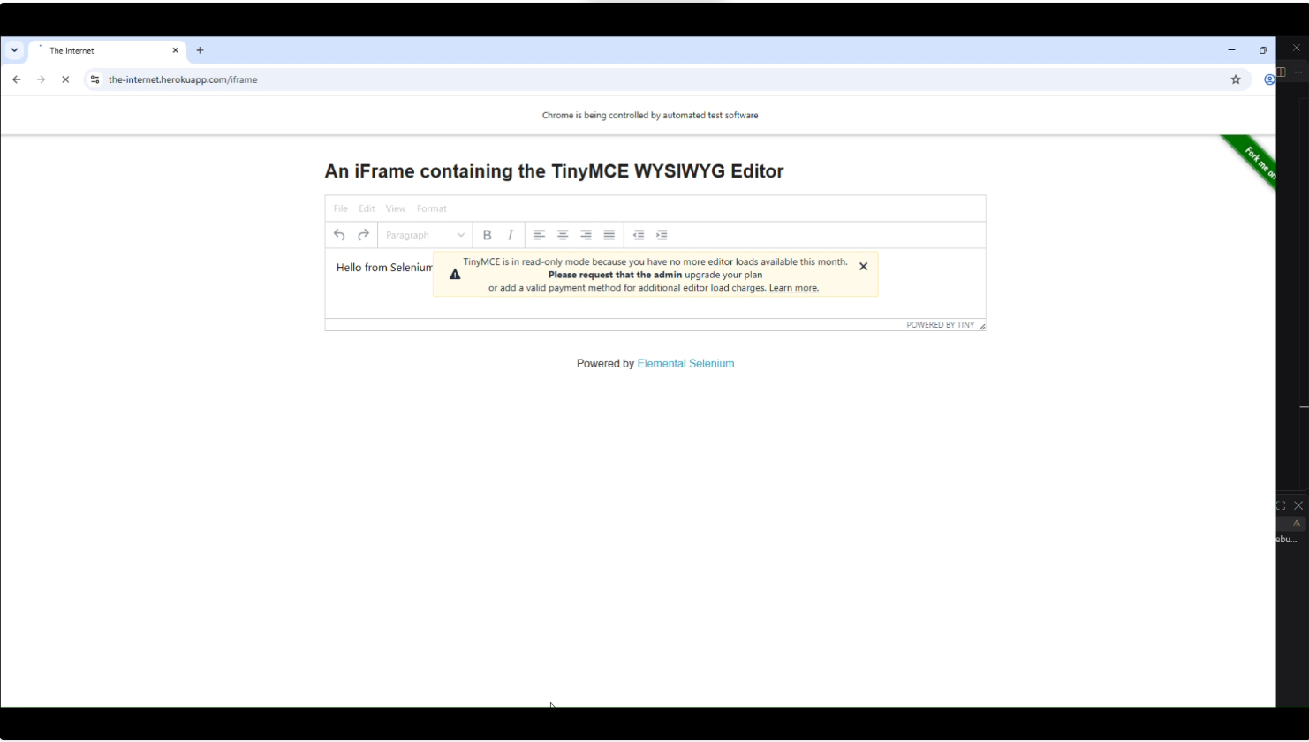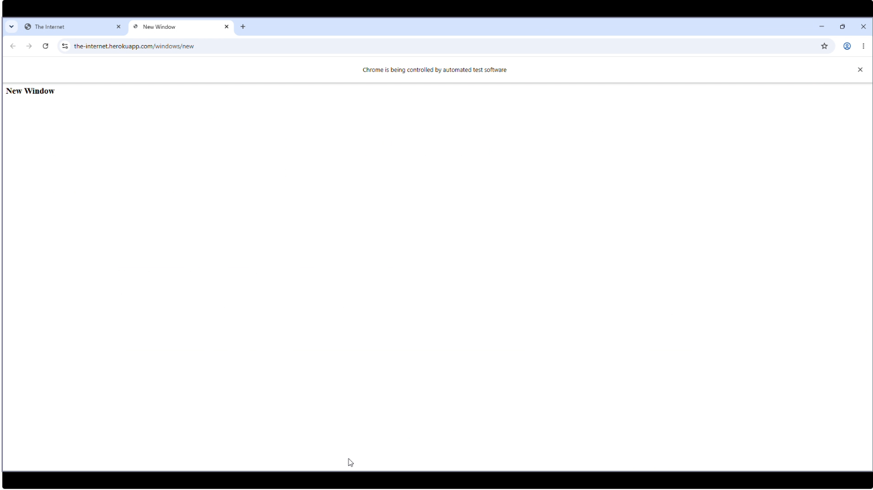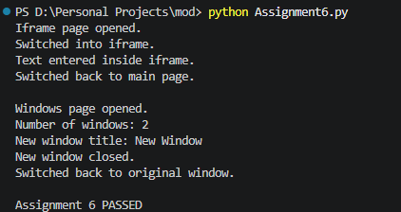

Expected Output
Iframe page opened.
Switched into iframe.
Text entered inside iframe.
Switched back to main page.

Windows page opened.
Number of windows: 2
New window title: New Window
New window closed.
Switched back to original window.

Assignment 6 PASSED

Result and Observation
The iframe was accessed by switching Selenium into the iframe context, and the TinyMCE editor was updated successfully. The script then handled a second browser context, retrieved the new window title, closed the new window, and returned to the original window.

Conclusion
The experiment demonstrated context switching in Selenium for both iframes and multiple browser windows/tabs. It also demonstrated keyboard actions for a contenteditable editor.

Overall Module Result
The Automation with Selenium module was completed through six practical experiments covering the core and advanced WebDriver concepts specified in the lab assignment. The experiments progressed from basic element identification and synchronization to dynamic controls, JavaScript dialogs, web-table traversal, iframe interaction, and multiple browser-window handling.

Overall Observation
- Different locator strategies are required depending on the structure and attributes of web elements.
- Explicit waits improve synchronization with dynamic web pages and avoid unnecessary fixed delays.
- Checkbox state can be verified programmatically using is_selected().
- Dynamic autocomplete components may re-render their DOM, so stale element references must be handled carefully.
- JavaScript alerts, confirms, and prompts require switching Selenium's context to the alert object.
- HTML tables can be traversed systematically by first locating the table, then its rows and cells.
- Iframes require switching into the frame before interacting with their internal elements.
- Multiple tabs or windows require window handles and explicit context switching.

Overall Conclusion
The experiments provided hands-on understanding of Selenium WebDriver automation using Python. The completed work demonstrates the ability to identify web elements, synchronize with dynamic content, operate complex controls, extract structured data, and manage multiple browser contexts. These concepts form the practical foundation for developing reliable browser automation scripts.

